Pin & Board Descriptions with Annotations SOP
1. Take the KW from the Overview Sheet.
2. Go to Pinclicks > Top Pins > Enter your KW > Export > Annotated Interests.
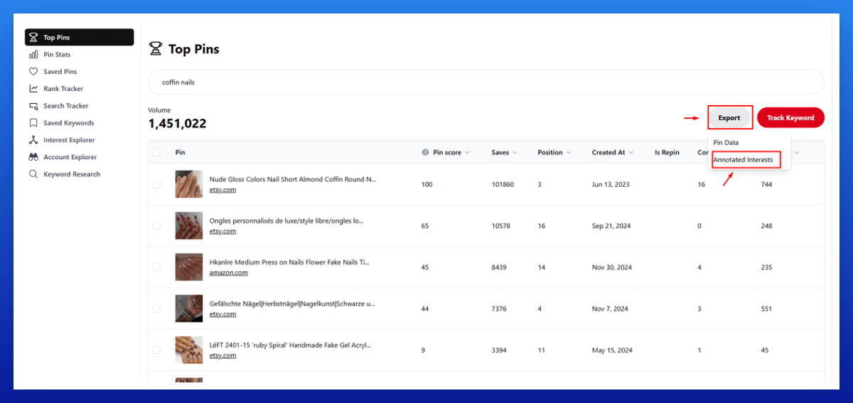
3. Open Google Sheets.
4. Go to File > Open > Upload and upload the Annotation CSV.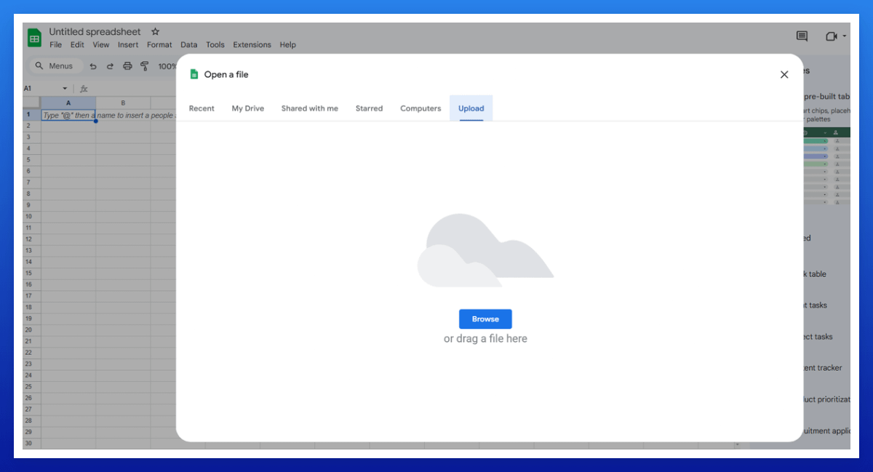
5. Select column B > right-click > choose "Sort sheet Z to A."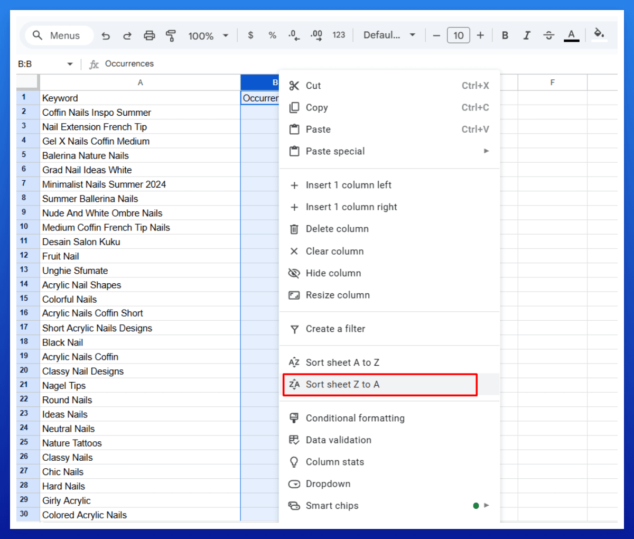
6. Pick 5 relevant annotations ("Occurrences" – higher numbers mean higher relevance, pick them first).
7. Create descriptions using ChatGPT or Grok.
8. Add the completed descriptions to the Overview Sheet.
Pin Description Prompt:
Please create a personal, human-sounding Pinterest description (within 500 characters) for my pin with this keyword: [Insert KW].
Include a short CTA like 'Read Now' or 'Save for Later' at the end. [Insert 4 annotations]
Board Description Prompt:
Please create a personal, human-sounding Pinterest board description that includes these keywords. Keep it within 300 characters and use the keywords as an exact match. [Insert your KW and 4 annotations]

